UNIT 4: COMMUNITY SERVICES
A. VOCABULARY
Lesson 1
bake sale (n)  /beɪk seɪl/ | The bake sale takes place all day.
Car wash (n)

/kɑr wɑʃ/
Contact (v) (n)  /ˈkɑnˌtækt/ | Please contact me when you arrive.  I lost my contact with him after he moved to a different city.
Craft fair (v)  /kræft fɛr/ | Let’s have a craft fair to raise money for children.
Fun run (n)  /fʌn rʌn/ | Why don’t we take part in the fun run next Sunday?
Right (n)  /raɪt/ | Every child has the right to get an education.
stuffed animal (n)

/stʌft ˈænəməl/
United Nations (n)

/juˈnaɪtəd ˈneɪʃənz/
Volunteer (n)  /ˌvɑlənˈtɪr/  Volunteer (v) to do sth | A volunteer is someone who does work without getting any money for it.  John volunteered to help organize the charity event this weekend.
Workshop (n)

/ˈwɜrkˌʃɑp/
Clean up (v)  /klin ʌp/ | We cleaned up the park near our school last weekend.
Clean-up (n)

/klin ʌp/
Donate (v)  /ˈdoʊˌneɪt/ | Last week, lots of students donated books and clothes to poor children in their town.
Raise money (v)  /reɪz ˈmʌni/ | They organized a charity event to raise money for the local children's hospital.
Recycle (v)  /riˈsaɪkəl/ | We planned to recycle all those papers two weeks ago.
Homeless (adj)  /ˈhoʊmləs/ | The homeless man sleeps in the park
Take place (v)
take part in (v)=join (v) | It’s free to take part in the fun run.

B. GRAMMAR
I. Suggestions
We can make suggestions to offer ideas or plans for someone to think about.
- Should + Vo
We should collect these old newspapers and papers for recycling.
- Let’s + Vo.
Let’s raise money for the poor at this time.
- Let’s (not) + Vo (Negative suggestions)
Let’s not throw trash here.
- How about + V-ing?
How about organizing a music show on Sunday?
- How about + S + Vo?
How about we organize a charity event this weekend?
II. Past Simple with regular verbs:
1. Cách dùng:
We use the Past Simple to talk about an action that started and finished in the past.
- yesterday (hôm qua)
- last night/week/month/... (Tối qua/tuần trước/tháng trước..)
- ago (cách đây), (two hours ago: cách đây 2 giờ/ two weeks ago: cách đây 2 ngày...)
- in + thời gian trong quá khứ (e.g: in 1990)
- when: khi (trong câu kể)

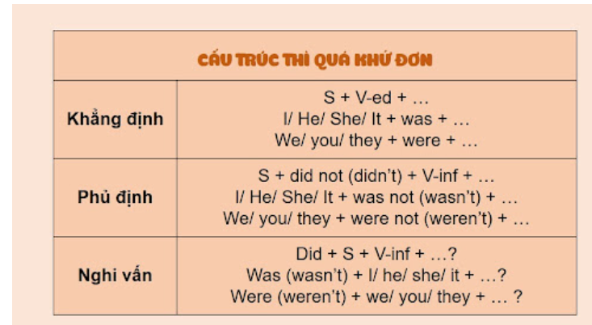

C. PRACTICE
Lesson 1
II. Choose the correct word.
1. Let’s organize/ organizing a charity event to support for poor students in our village.
3. How about raise/ raising more money for poor people before Tet Holiday?
4. Let’s not use/ using this car more because it is too old.
5. We should donate/ donating old books and clothes for children who are living in remote area.
6. How about we use/ using the money from these events to buy clothes, books, food for poor people?
7. I’m not good at English. Let’s ask/ asking my sister to help these exercises.
8. I think we should sell/ selling these paintings to get some money.
9. How about help/ helping our local community on the weekend?
Lesson 2
II. Give the correct form of the verbs in brackets.
1. Last Saturday, Anna and his friends (volunteer)__________ at the soup kitchen.
2. We (clean up)__________ the park near our school last weekend.
3. My parents (raise)__________ money to help the local children's hospital two years ago.
4. Last week, lots of students (donate)__________ books and clothes they (not use)__________ any more to poor children in their town.
5. Our school (collect)__________ all of the donations and sent them to poor people.
6. They (plant)__________ frees in the streets to make their town cleaner.
7. Jenny (take)__________ a lot of photos last week.
8. My brother (wash)__________ his car yesterday morning.
9. We (help)__________ some poor children in our neighborhood study English last year.
10. We (plan)__________ to recycle all those papers two weeks ago.
Lesson 3
TEST FOR UNIT 4
I. Choose the words whose underlined part is pronounced differently from that of the others in each group.
1. A. sale B. nation C. bake D. contact
2. A. fun B. run C. argue D. stuffed
3. A. craft B. cycle C. country D. car
4. A. sure B. sign C. support D. serving
5. A. please B. beach C. clean D. weather
6. A. free B. need C. volunteer D. weekend
7. A. workshops B. animals C. books D. rights
8. A. cupcakes B. experiences C. organizes D. crosses
9. A. introduced B. donated C. decided D. collected
10. A. picked B. liked C. stopped D. happened
II. Choose the word whose main stressed syllable is placed differently from that of the other in each group.
11. A. donate B. talent C. workshop D. contact
12. A. artist B. event C. homeless D. money
13. A. sweater B. kitchen C. report D. cleaner
14. A. recycle B. vacation C. important D. organize
15. A. competition B. opinion C. environment D. community
III. Choose the best answer to complete each sentence.
16. Who__________ Maria volunteer with last year?
A. is B. was C. does D. did
17. What kinds__________ things could you do to help your local community?
A. on B. for C. of D. off
18. I stayed at home alone last night. It made me__________ sad and nervous last night.
A. to feel B. feel C. feeling D. felt
19. The weather is so beautiful today.__________ go to the beach.
A. Let’s B. How out C. Why don’t D. What about
20. We should__________ the yard every day.
A. cleaning B. cleaned C. to clean D. clean
21. This vacation wasn’t the same__________ last year.
A. to B. with C. as D. on
22. Vinfast__________ two new electric cars VF8 and VF9 models in the USA two months ago.
A. introduce B. introduced C. introducing D. introduces
23. My class raised money__________ some poor children in my neighborhood.
A. to help B. helping C. help D. helps
24. How many volunteers__________ to pick up trash on the beach last Sunday?
A. helping B. helped C. helps D. to help
25. What about__________ the clean-up to keep our environment fresh?
A. organize B. organized C. to organize D. organizing
IV. Supply the correct forms of the given words to complete the sentences.
26. People admires his__________ for the community. (donate)
27. The__________ of this organization hopes to gather more vonlunteers. (lead)
28. I think we should help__________ people in our town. (home)
29. We are going to do these__________ next week to raise money foor poor students. (act)
30. Let’s bring__________ to children every day. (happy)
V. Choose the word which best fits each gap.
Doing some form of voluntary work has (31)__________ been more popular with British people. Over 20 million people were engaged (32)__________ voluntary activities in 2013. Volunteering means giving up time to do work of (33)__________ to the community. It can be based in the UK or overseas. Volunteering can take many forms, from working with children with (34)__________ difficulties, in an animal hospital, or planting trees. (35)__________ London won its bid to host the 2012 were needed to Olympics, up to 70,000 volunteers help ensure the games were a success.
31. A. ever B. never C. any D. before
32. A. in B. for C. in D. to
33. A. profit B. contribute C. comfort D. benefit
34. A. learn B. learning C. learned D. to learn
35. A. When B. Where C. While D. What
VI. Read the text and choose the correct answer.
Each country has many good people who take care of others. For example, some of students in the United States often spend many hours as volunteers in hospitals, orphanages or homes for the elderly. They read books to the people in these places, or they just visit them and play games with them or listen to their problems.
Other young volunteers go and work in the homes of people who are sick or old. They paint, clean up, or repair their houses, do the shopping. For boys who don't have fathers, there is an organization called Big Brothers. College students and other men take these boys to basketball games or on fishing trips and help them to get to know things that boys usually learn from their fathers.
Each city has a number of clubs where boys and girls can go and play games. Some of these clubs show movies or hold short trips to the mountains, the beaches, museums, or other places of interest. Most of these clubs use a lot of students as volunteers because they are young enough to understand the problems of younger boys and girls.
36. What do volunteers usually do to help those who are sick or old in their homes?
A. They tell them stories and sing and dance for them.
B. They do shopping, and repair or clean up their houses.
C. They cook, sew, and wash their clothes.
D. They take them to basketball games.
37. What do they help boys whose father do not live with them?
A. To learn things that boys usually learn from their fathers.
B. To get to know things about their fathers.
C. To get to know things that boys want from their fathers.
D. To learn things about their fathers.
38. Which activity is NOT available for the students at the clubs?
A. playing games B. watching films
C. going to interest places D. learning photography
39. Why do they use many students as volunteers? - Because__________.
A. they know how to do the work
B. they have a lot of free time
C. they can understand the problems of younger boys and girls
D. they are good at playing games and learning new things
40. Where don't students often do volunteer work?
A. hospitals B. orphanages
C. homes for the elderly D. clubs
VII. Rewrite the following sentences without changing the meaning.
41. Kelly is fond of doing charity work with her classmates on the weekends. (enjoys)
→ Kelly__________________________________________________________________
42. What type of charity event should we organize? (kind)
→ What__________________________________________________________________
43. Let’s help poor children in our village.
→ How about_____________________________________________________________
44. They will organize a bake sale to raise money.
→ A bake sale_____________________________________________________________
45. Designing these posters is very difficult.
→ It is___________________________________________________________________
VIII. Put the words in the correct order to make correct sentences.
46. We/ ask/ parents/the poor students./ to donate/ our/ old clothes/ should/ for
_________________________________________________________________________
47. I/ good/ not/ making/ cakes./ am/ at
_________________________________________________________________________
48. Let’s/ have/ at/ the school gate./ the craft fair
_________________________________________________________________________
49. Our school/ the charity week. /over ten million dong/ raised/ after
_________________________________________________________________________
50. What/ things/ of/ could/ do/ kinds/ your local community?/ you/ to help
_________________________________________________________________________
Tiếng Anh 7 – i-LEARN SMART WORLD

UNIT 4 TEST
Note: Each correct answer earns 0.2 points.

I. PRONUNCIATION (0.8 points)
A. Choose the word whose underlined part is pronounced differently.
1. A. washed B. picked C. cleaned D. helped
2. A. reused B. recycled C. raised D. donated
B. Choose the word that has a different stressed syllable from the rest.
3. A. support B. talent C. event D. collect
4. A. volunteer B. charity C. organize D. decorate

II. VOCABULARY AND GRAMMAR (2.4 points)
Choose the best option (A, B, C or D) to complete each of the following questions.
5. Every child has the __________ to get an education.
A. talent B. activity C. right D. event
6. Last summer, my class collected bottles and cans for __________.
A. recycling B. raising C. cleaning up D. reducing
7. We __________ old textbooks, unused notebooks and spare stationery to help students in mountainous areas.
A. raised B. picked C. took D. donated
8. A(n) __________ is someone who does work without getting any money for it.
A. charity B. volunteer C. organization D. community
9. We __________ organize a charity car wash. It’s an easy and fun way to raise money.
A. shouldn’t B. need C. should D. would like
10. __________ are a popular way to raise money for schools and clubs because lots of people love cakes, cookies, muffins, pies and biscuits.
A. Bake sales B. Craft fairs C. Talent shows D. Garage sales
11. We took part ______ the charity walk for Children in Need yesterday, and it was great fun.
A. on B. in C. with D. for
12. Many schools hold __________ every year because they are fun and give students a chance to show off their special skills, such as singing, dancing or doing magic tricks.
A. school fairs B. car washes C. art shows D. talent shows
13. Last month, we __________ a lot of trees in the schoolyard. It was so much fun.
A. collected B. raised C. planted D. donated
14. Student A: “What did you do to help our community?”
Student B: “_________”
A. I want to volunteer at a soup kitchen.
B. I made cards to sell at the school fair.
C. I like planting trees in the park.
D. I think I will donate books and clothes.

15. Read the poster and choose the correct statement.
 | A. You have to wear a pink uniform.  B. There are events for both children and adults.  C. It’s free to take part in the fun run.  D. You can check in at 8 a.m.

16. Read the poster and choose the correct statement
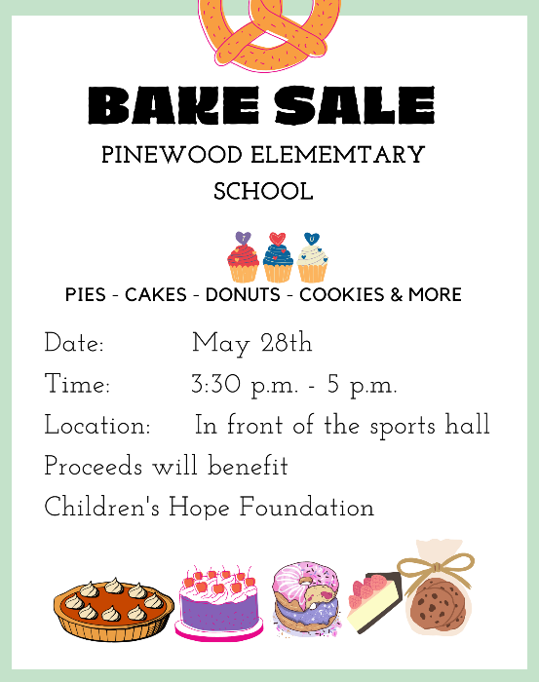 | A. The bake sale takes place all day.  B. The bake sale takes place indoors.  C. The bake sale is for elementary students.  D. The bake sale raises money for Children’s Hope Foundation.
III. WORD FORMATION (1.2 points)
Write the correct form or compound of the words in brackets.

There are (17) __________ ways that you can do to help the community.  - Work as a volunteer at an animal shelter. You can help taking care of (18) __________ animals by feeding or bathing them.  - Make a (19) __________ to charity projects.  - Spend some time at an orphanage. You can bring (20) __________ to orphan kids by playing with them or teach them music and crafts.  - Take part in community (21) __________. You can pick up rubbish on the streets, sidewalks, beaches and parks, or clean the graffiti off the walls.  Little things you do can have an (22) __________ impact on the society. | (DIFFER)  (HOME)  (DONATE)  (HAPPY)  (CLEAN)  (AMAZE)

IV. LISTENING (2 points)
A. You will listen to Ms. White interviewing Annie Williams – a middle school student. For questions 23-27, complete the notes with NO MORE THAN TWO WORDS.

Last month, Annie donated (23) __________ and old toys to (24) __________ children.
Last week, Annie cleaned up the (25) __________ and planted flowers and trees there.
(26) __________, Annie volunteered at a (27) __________ with her friends.

B. You will listen to a radio show. For each question from 28 to 32, listen and choose the correct option A, B, C or D.

28. Green Steps organized clean-ups in _______ cities and towns.
A. 14 B. 30 C. 40 D. 56
29. Volunteers cleaned up parks and rivers in _____.
A. Palmdale B. Crabtree C. Greendale D. Pearl
30. In Crabtree, Green Steps volunteers ________.
A. picked up trash on the beach B. cleaned up the city
C. organized World Environment Day D. worked with local people
31. How many people took part in the clean-up at Pearl Beach?
A. 12 B. 20 C. 13 D. 800
32. Ms. Carrie Ford believes _______ is a serious problem.
A. trash along the streets B. plastic pollution
C. dirty beaches and rivers D. the environment

V. READING (2 points)
A. Read the following passage. For each of the questions from 33 to 37, write T if the statement is TRUE, F if the statement is FALSE and NI if there is NO INFORMATION on it.

Girl Scouts of the USA is the largest organization for girls in the world. Juliette "Daisy" Gordon Low organized the first group of Girl Scouts on March 12th, 1912. She wanted to give girls the opportunity to get out of the house and help their community. Girl Scouts of the USA started with 18 members. Today, there are about 2.5 million girl and adult members worldwide. The girls work on a variety of projects. Simple projects may involve sewing, or collecting toys for kids who live in shelters. Other community services for older girls includes volunteering at a soup kitchen, planting trees, doing car washes or cleaning up litter in their community. Girl Scouts is famous for raising money by selling delicious Girl Scout cookies. The girls bake cookies at home with their mums volunteering as an advisor. The organization believes that selling cookies helps Girl Scouts practice life skills like teamwork and money management. When they complete goals, they earn badges for their work which they wear on their sashes.

33. There were 18 girls joining the first Girl Scouts group.
34. Girl Scouts members do different community services.
35. To raise money, the girls sell cookies that their mothers make.
36. Girl Scouts raised a lot of money by selling cookies.
37. After finishing one goal, the girls receive a sash.

B. Read the online post. For questions from 38 to 42, choose the correct option A, B, C or D that best suits each blank.

Hi Ethan,
Last week, I (38) __________ in a color run in my city. It was a fundraising event for disabled children. More than two thousand people joined the event. It was a 5K run, and there were five stations around the track. Volunteers threw color powder at (39) __________ when they made their way through each station. The powder was cornstarch, so it was natural and safe. The (40) __________ part was the colored gel – it was cold and wet and coming at the runners from huge water guns. Runners started out wearing white T-shirts, and by the end of the run, they were covered in colors of red, green, purple and orange. It looked quite crazy, dirty and messy, (41) __________ it was super fun. After the run, there was a big music party with DJs and rock bands. It was so amazing. A color run is definitely something to do with friends. I want to do another one soon. Would you like (42) __________?
See you,
Nathan

38. A. had B. went C. took part D. organized
39. A. participants B. participation C. participated D. participating
40. A. most B. most interested C. more exciting D. best
41. A. because B. but C. however D. so
42. A. coming B. come C. to come D. to coming
VI. WRITING (1.6 points)
A. Rewrite the following sentences without changing their meaning. Use the given word(s) if any.
43. Let’s have a craft fair to raise money for children with special needs.
→ How .
44. We shouldn’t have the concert outdoors because it might be cold in the evening.
→ Let’s .
45. Why don’t we take part in the fun run next Sunday? (TAKE)
→ How ?
46. It’s a good idea to host a school-wide yard sale on the weekend.
→ We should .

B. Use the given words or phrases to make complete sentences.
47. Last month, my school/ organize/ a fun run/ raise money/ the local soup kitchen.
→
48. My brother/ work/ a volunteer/ Kenya/ last year.
→
49. I/ go/ a clean-up/ last week/ the forest.
→
50. you/ donate/ money/ help/ flood victims/ yesterday?
→

***End – Of – Test***

